Aafrin Project

Tours & Travels Website



Aafrin Sayani (2030150)

TAble of  
Contents

Tours & Travels Wesite 1 1

Homepage 1

About Page 2

Search Page 3

Trips Page 4

Feedback Page 5

Reference Page 6

# User Manual

Step 1: Login the website using Username: admin

Step 2: Login the website using Username: admin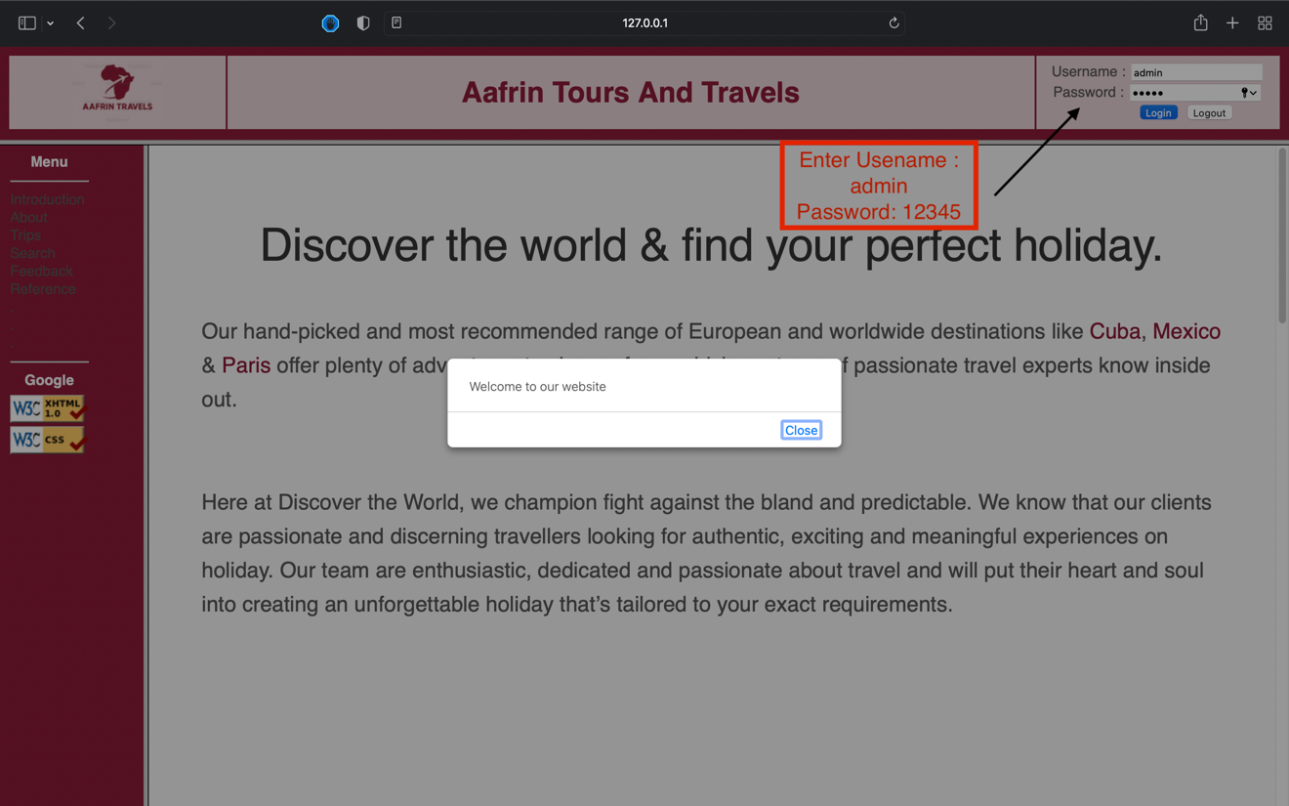

Step 3: Use Internal links to navigate the website

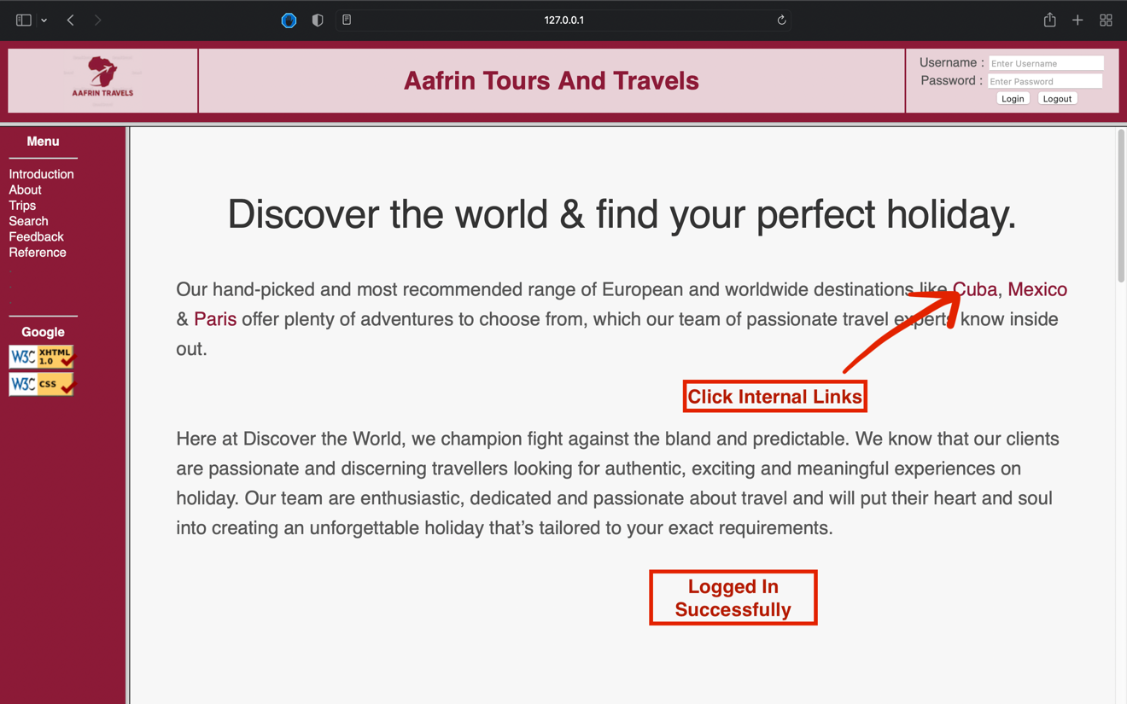

Step 3: Use Internal links to navigate the website

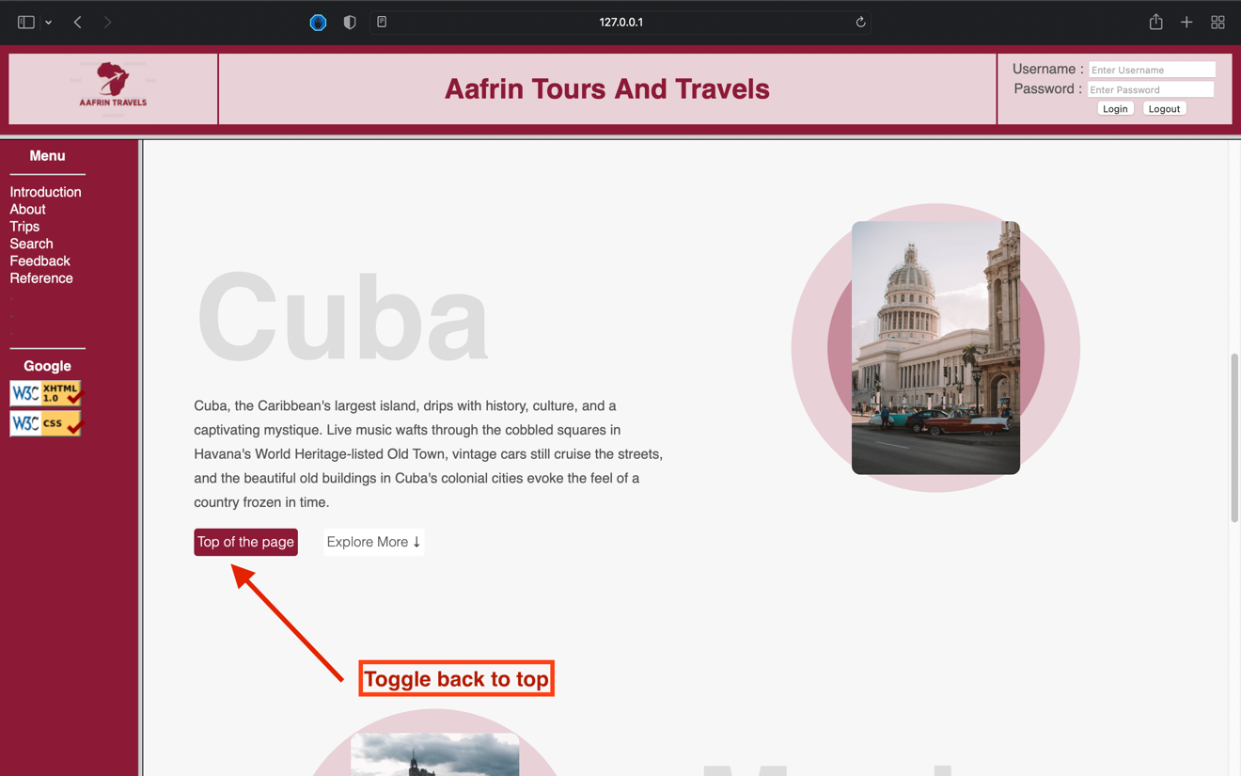

Step 3: Use Internal links to navigate the website

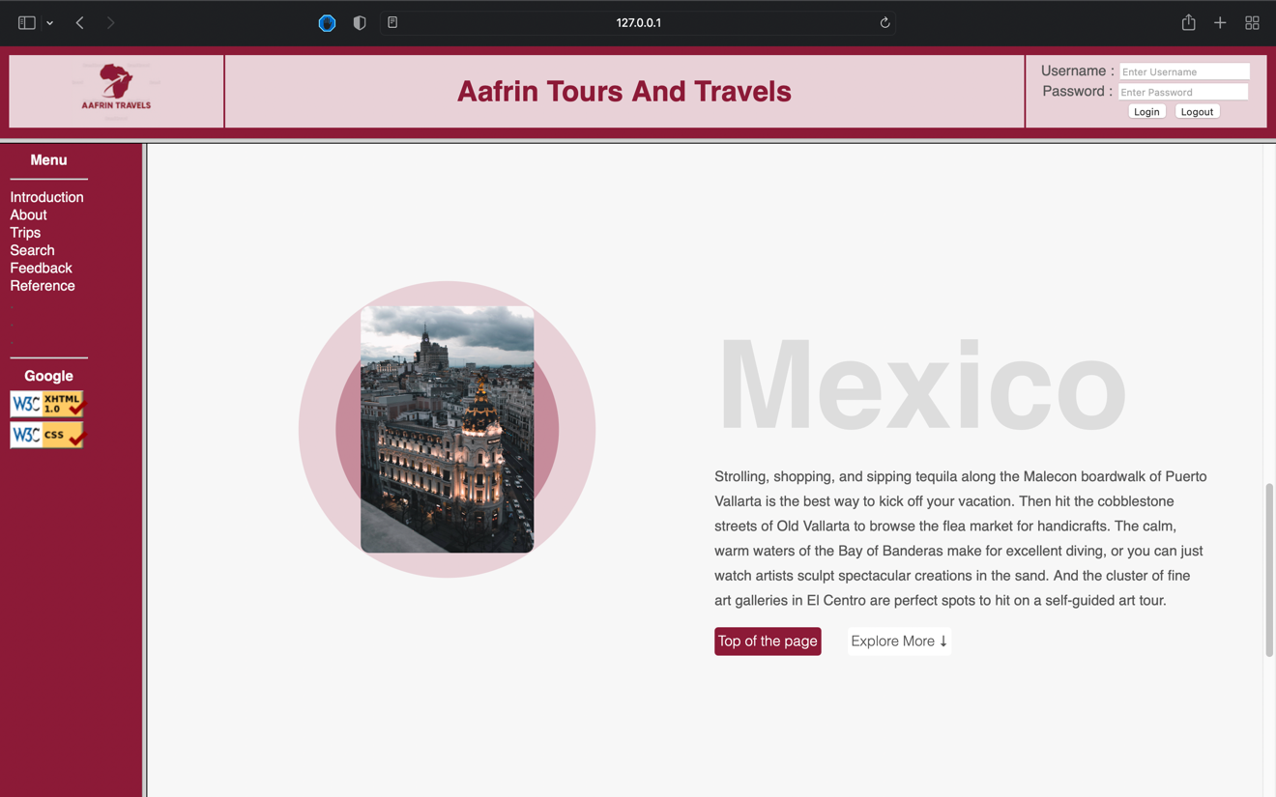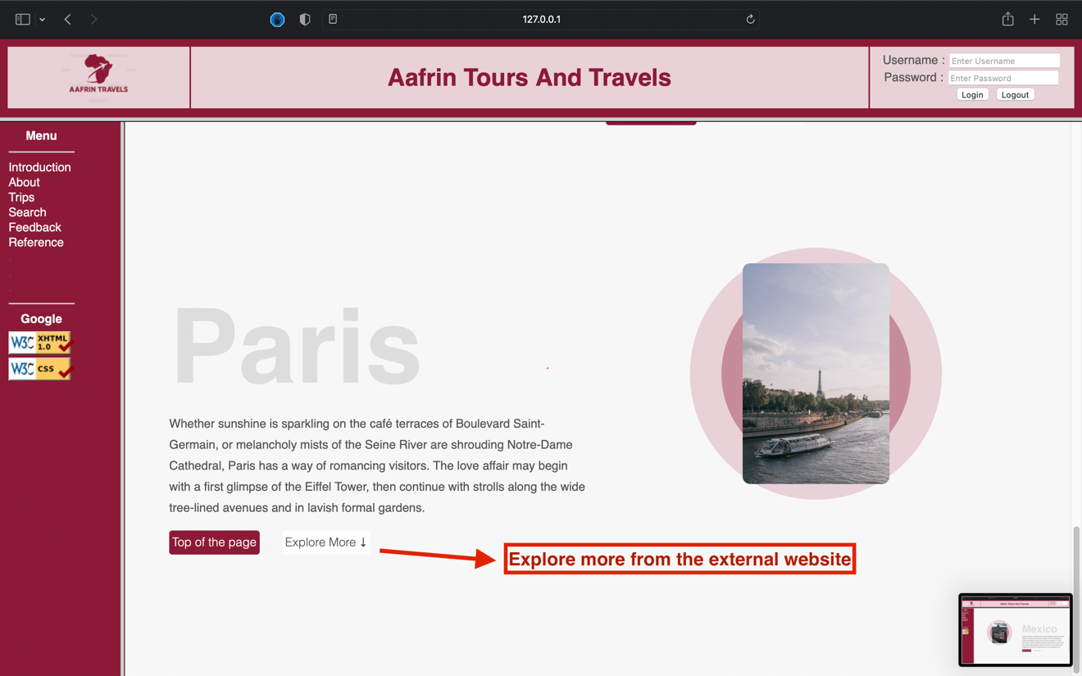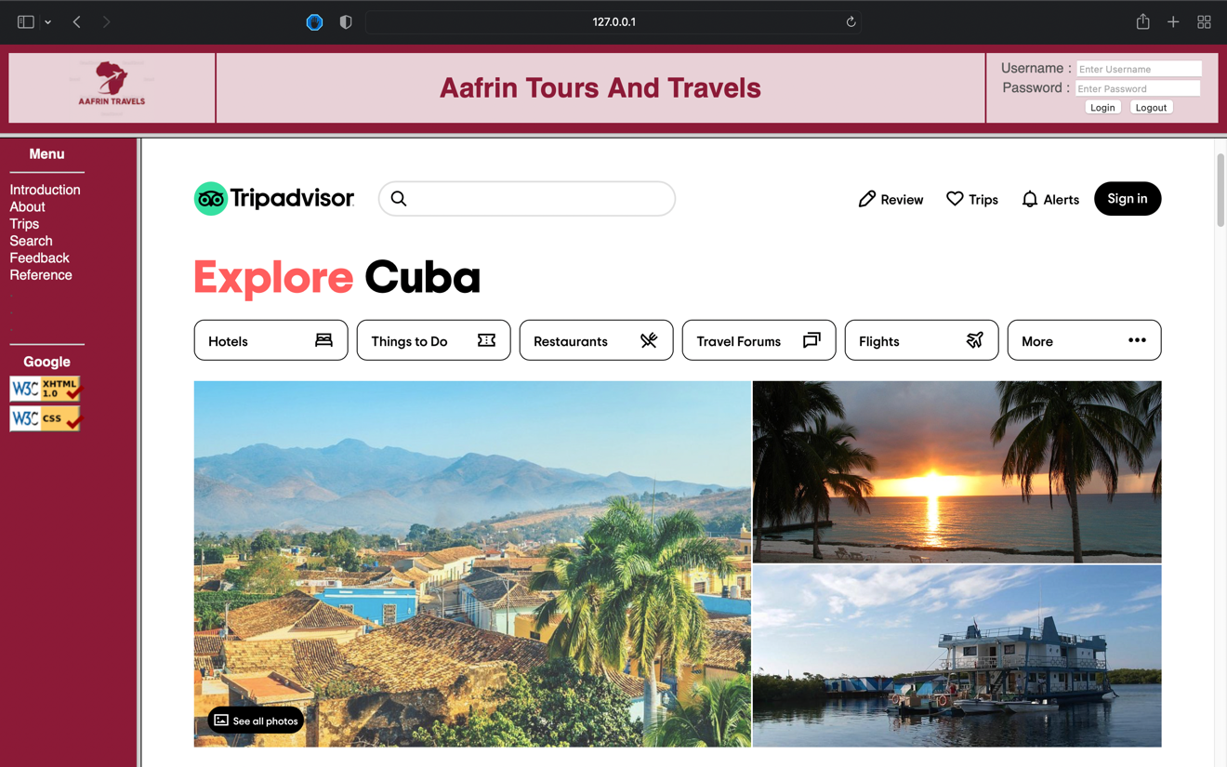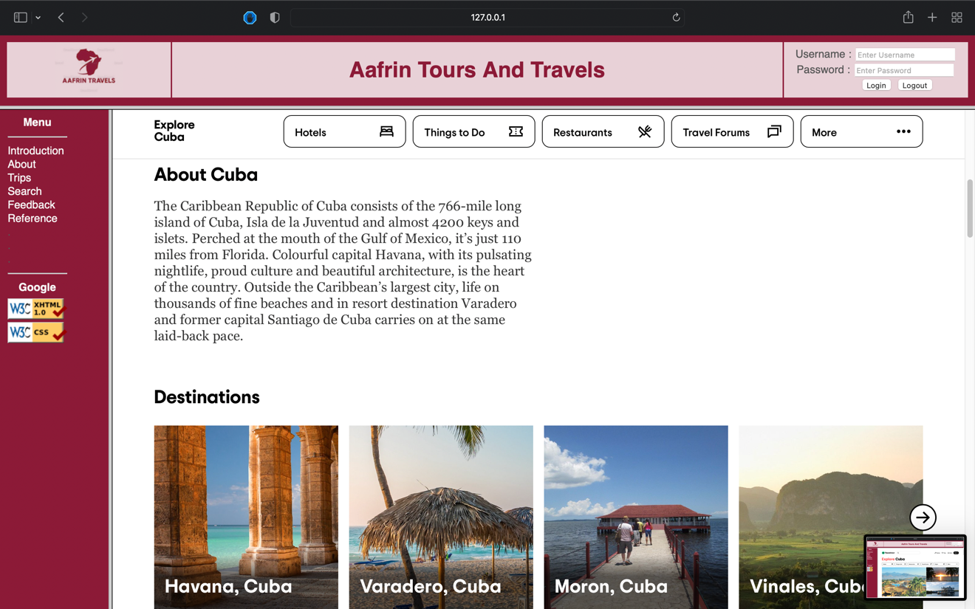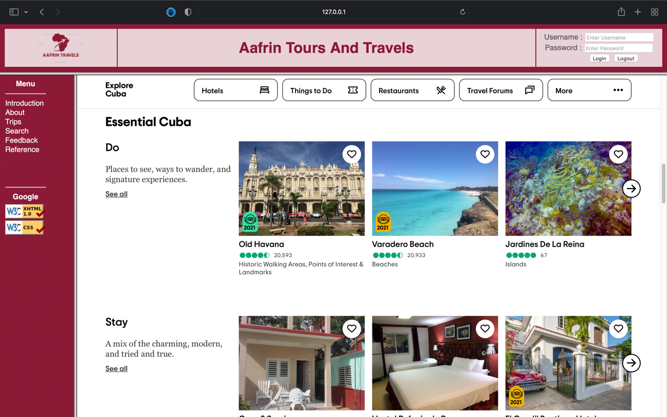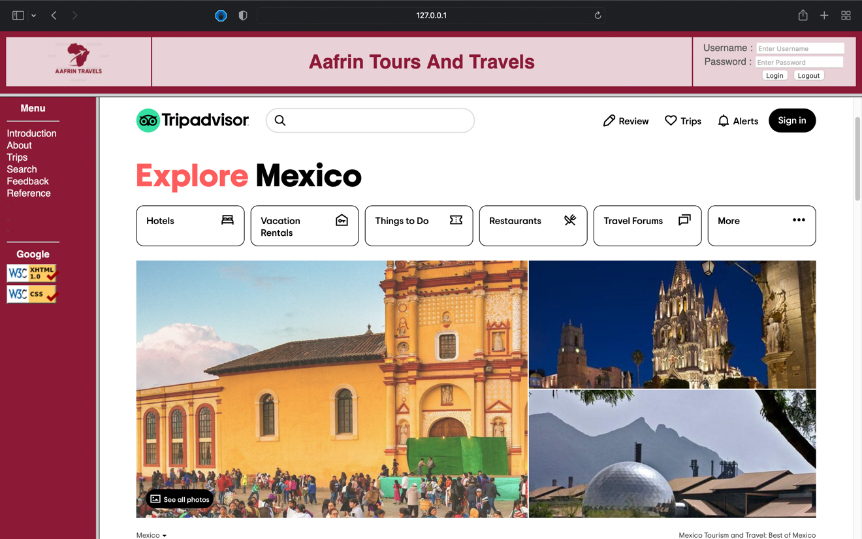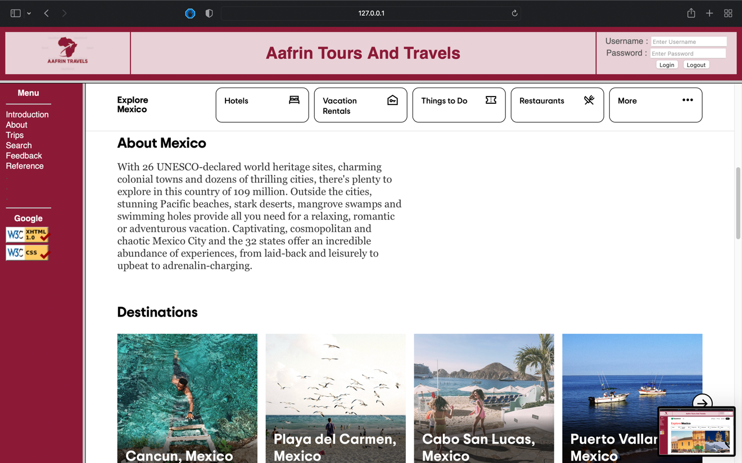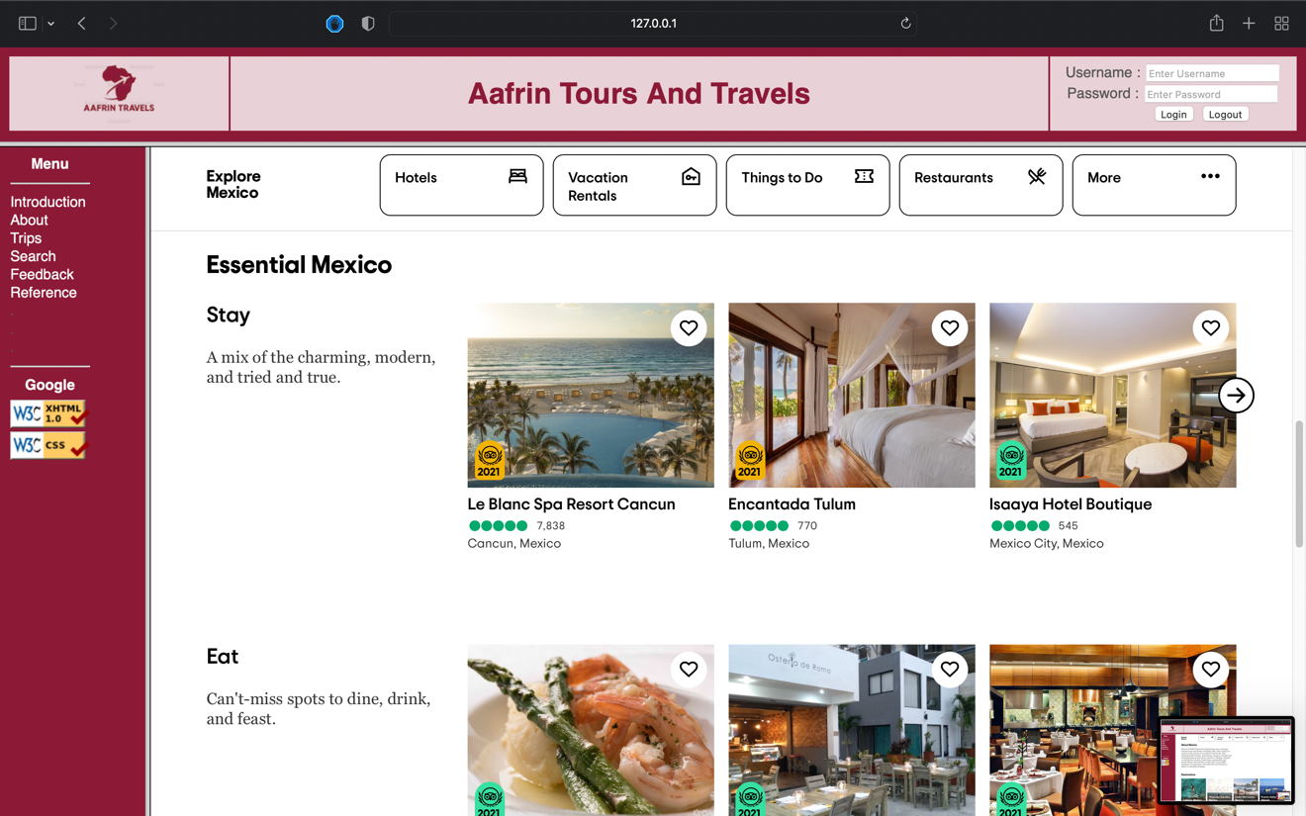

Step 4: Welcome page

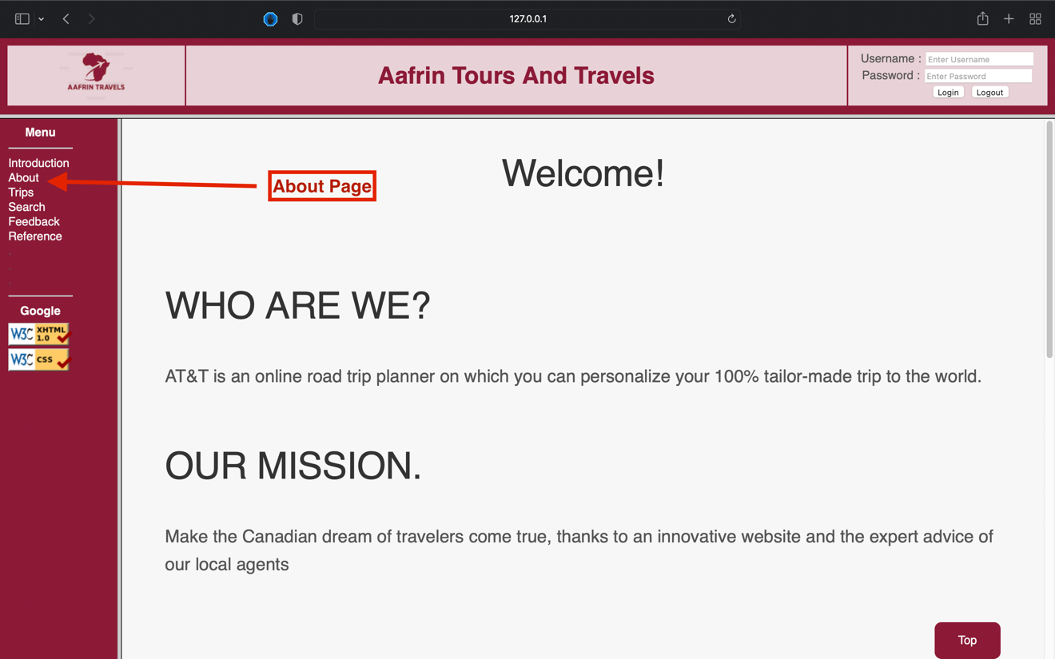

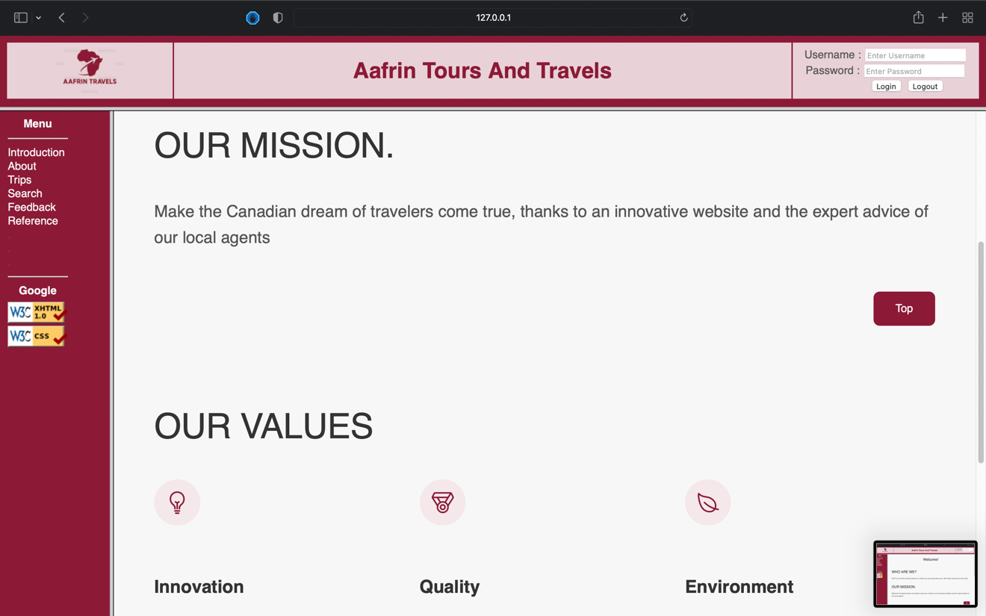

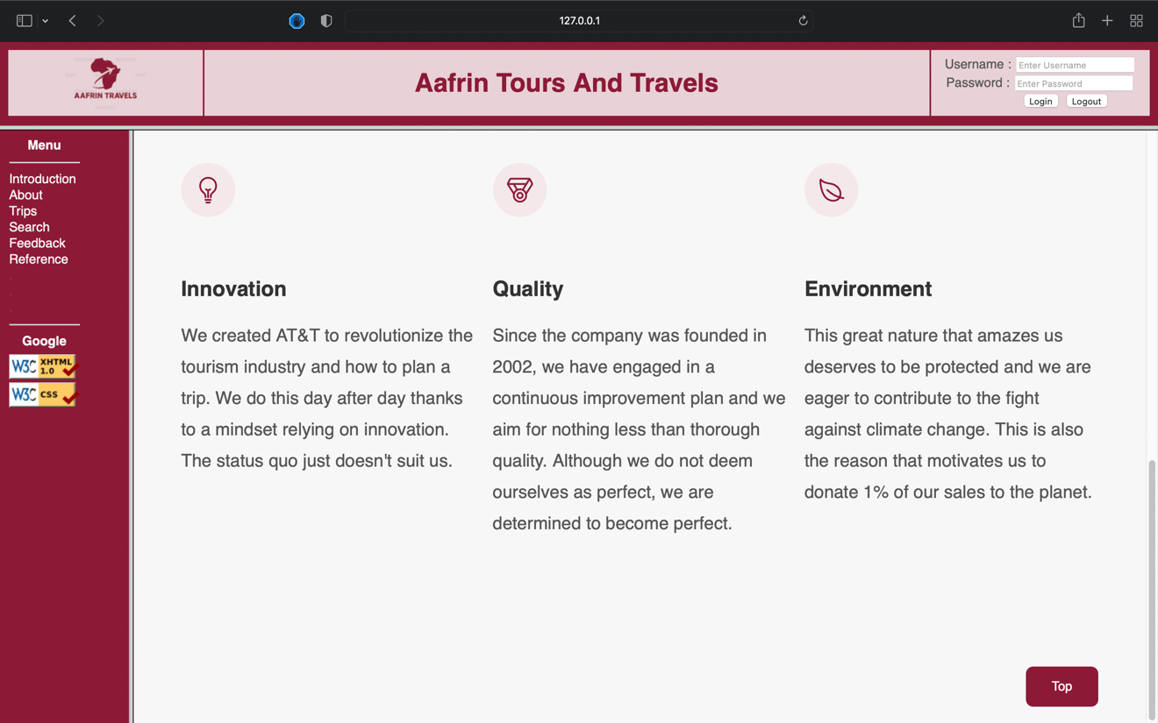

Step 5: Click the continents area suggested below to know more about the places to visit.

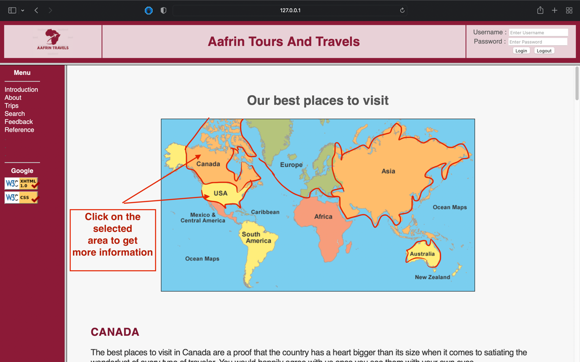

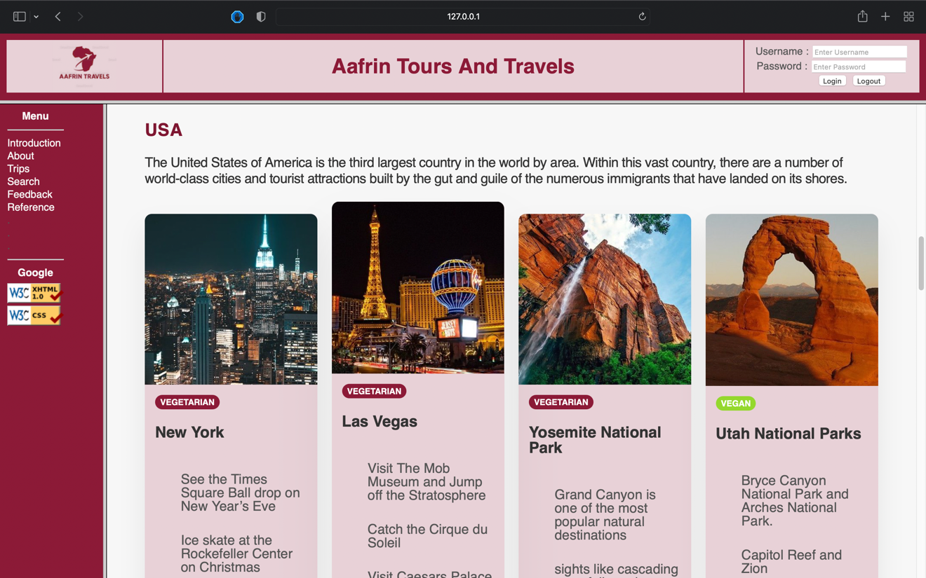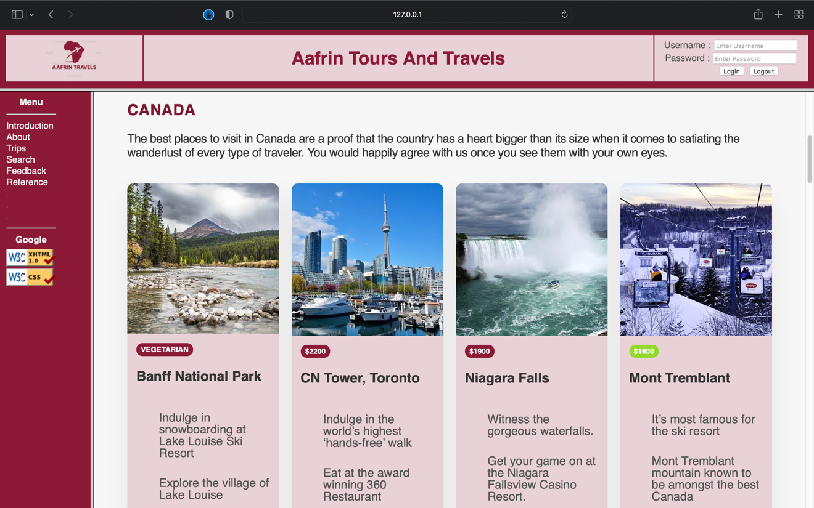

Step 7: Search the continent in the search bar.

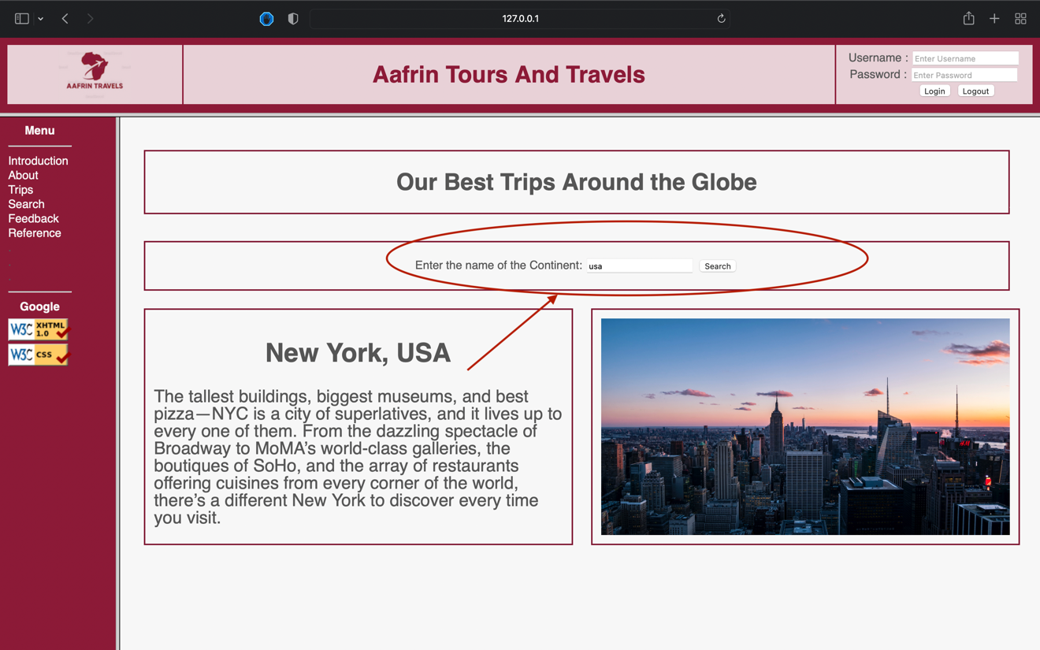

If Continent not found then it will show 404 & recommendations.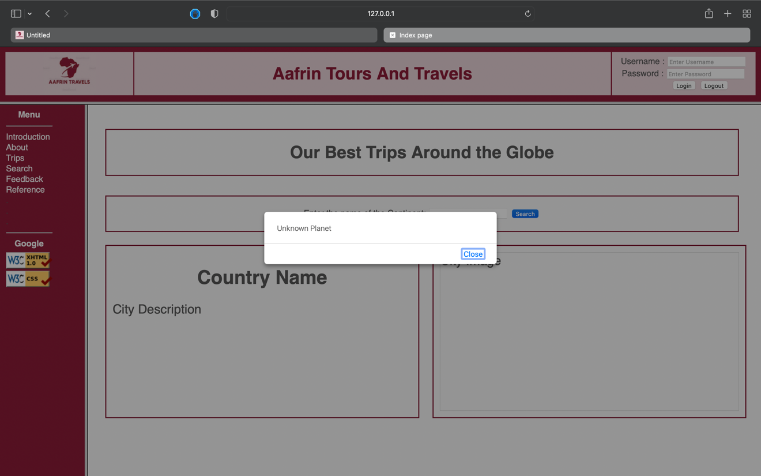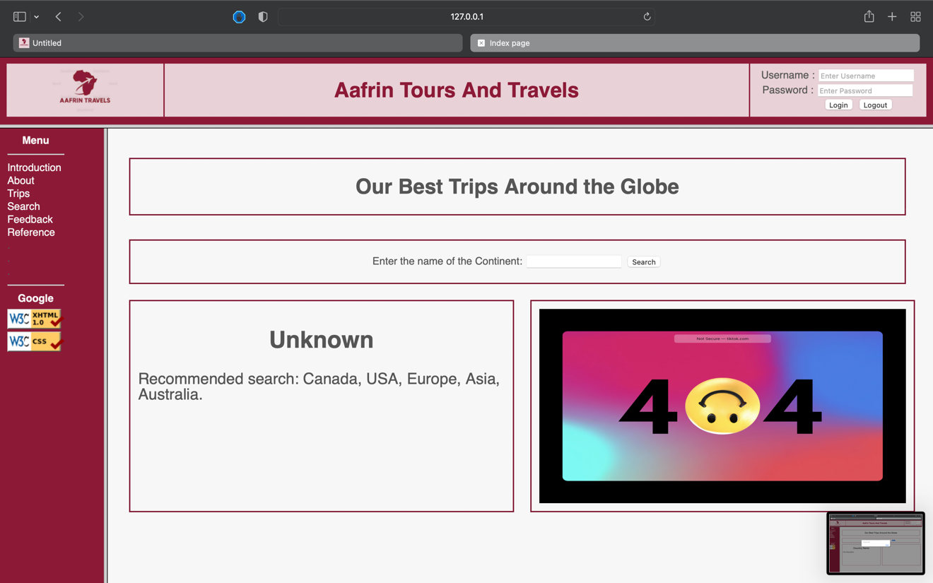

Step 7: Search the continent in the search bar.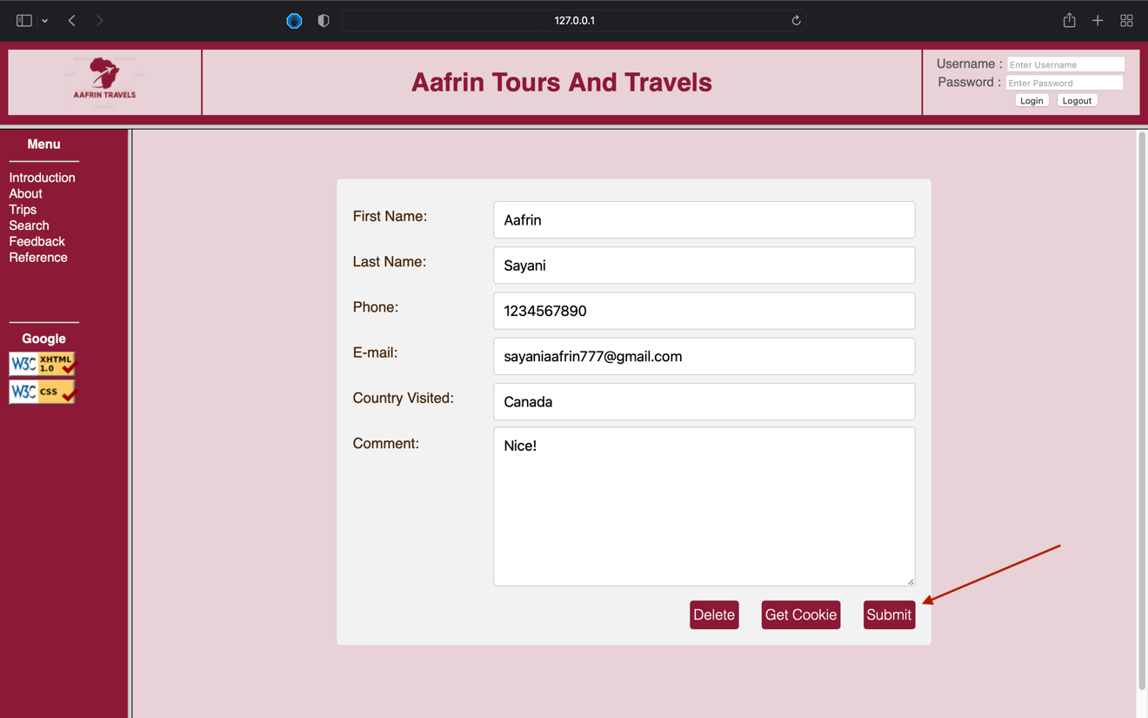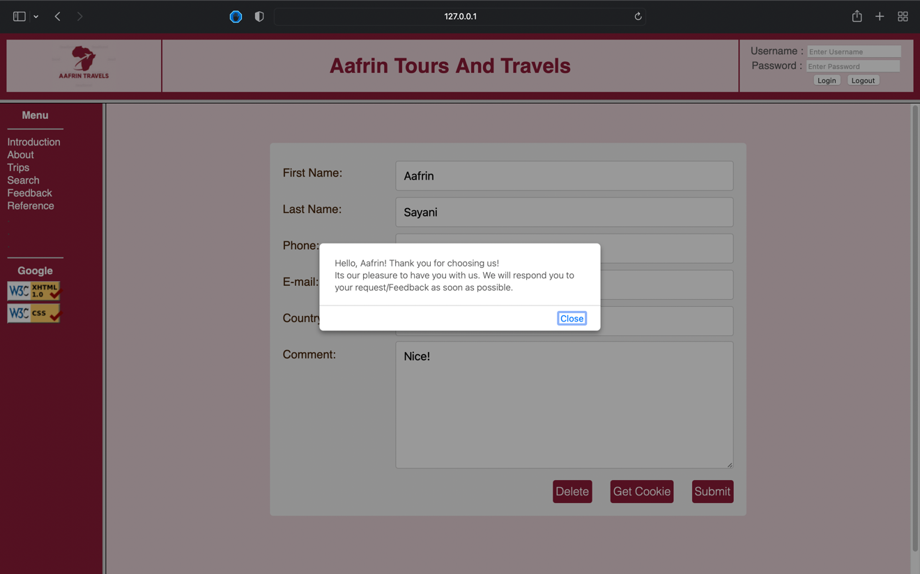

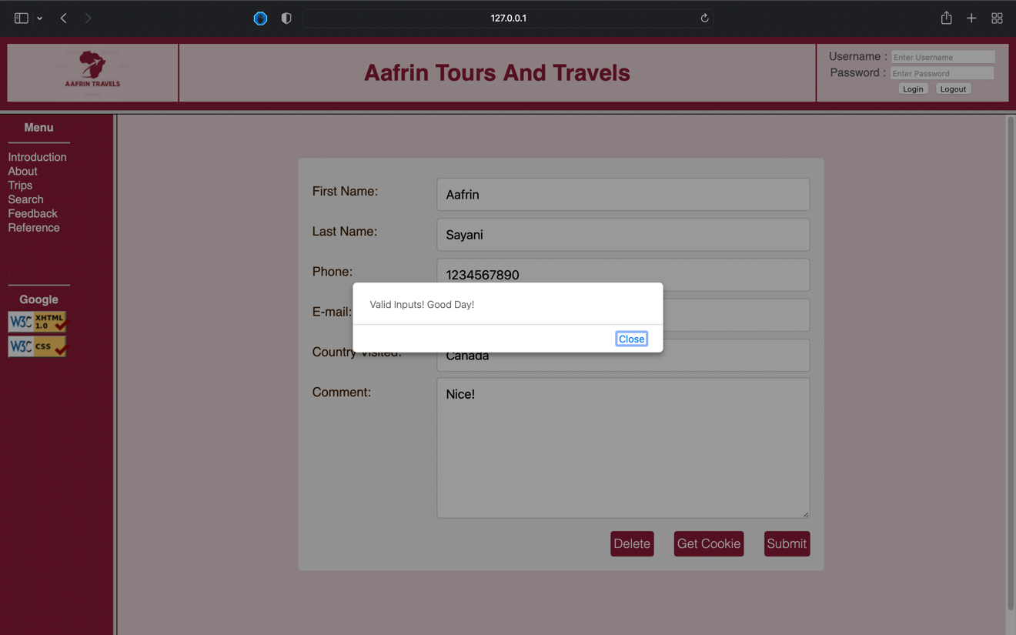

Step 8: Get Cookies

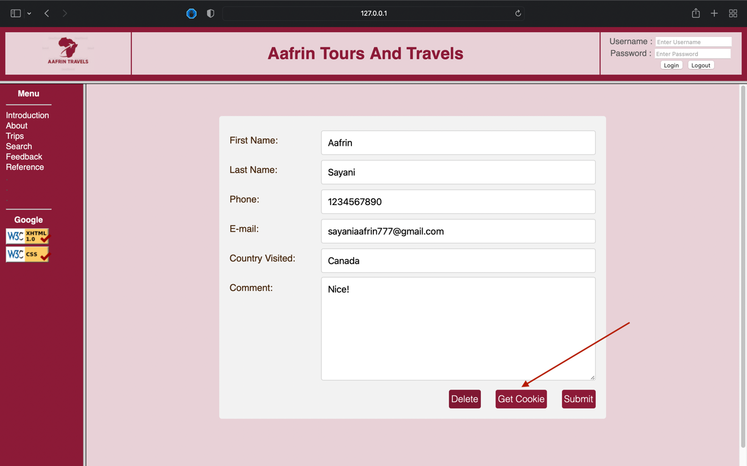

Step 8: Show the cookies on the next page with time consumed.

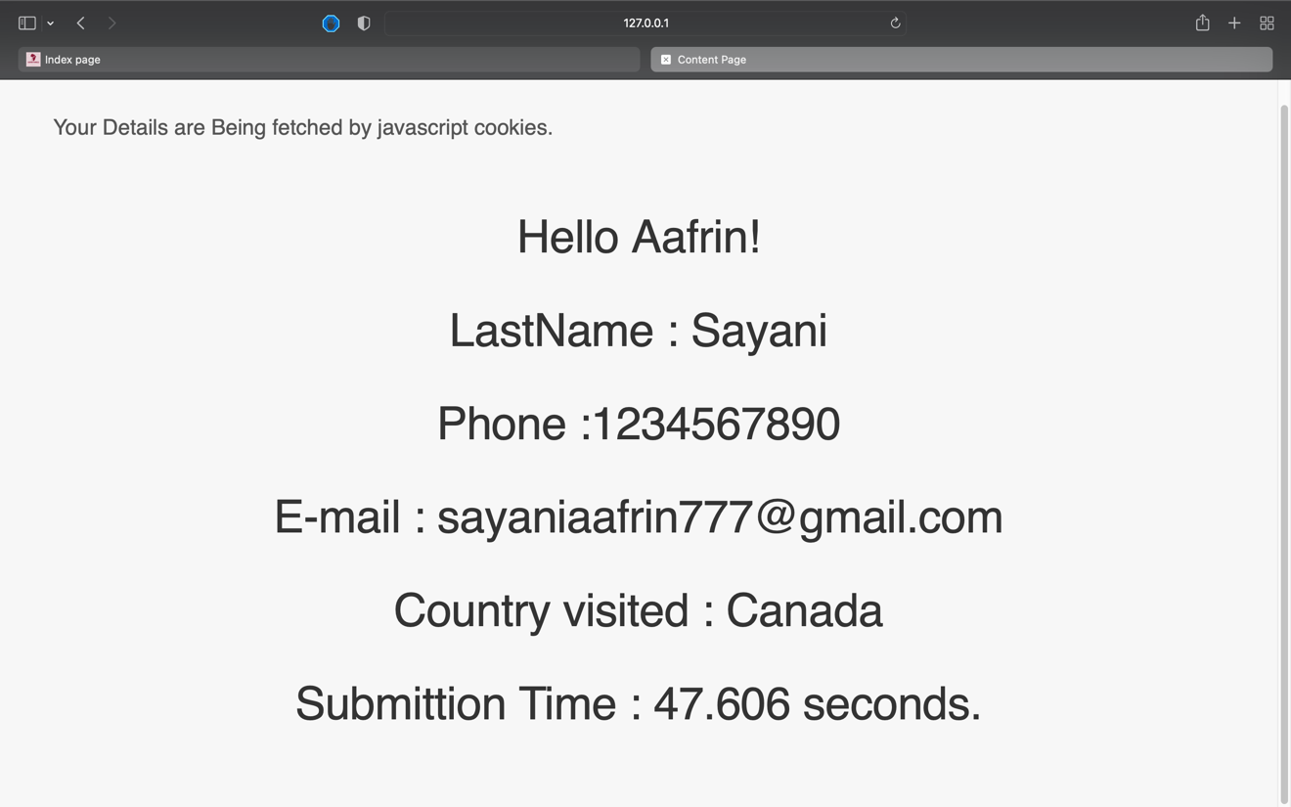

Step 9: Delete cookies.

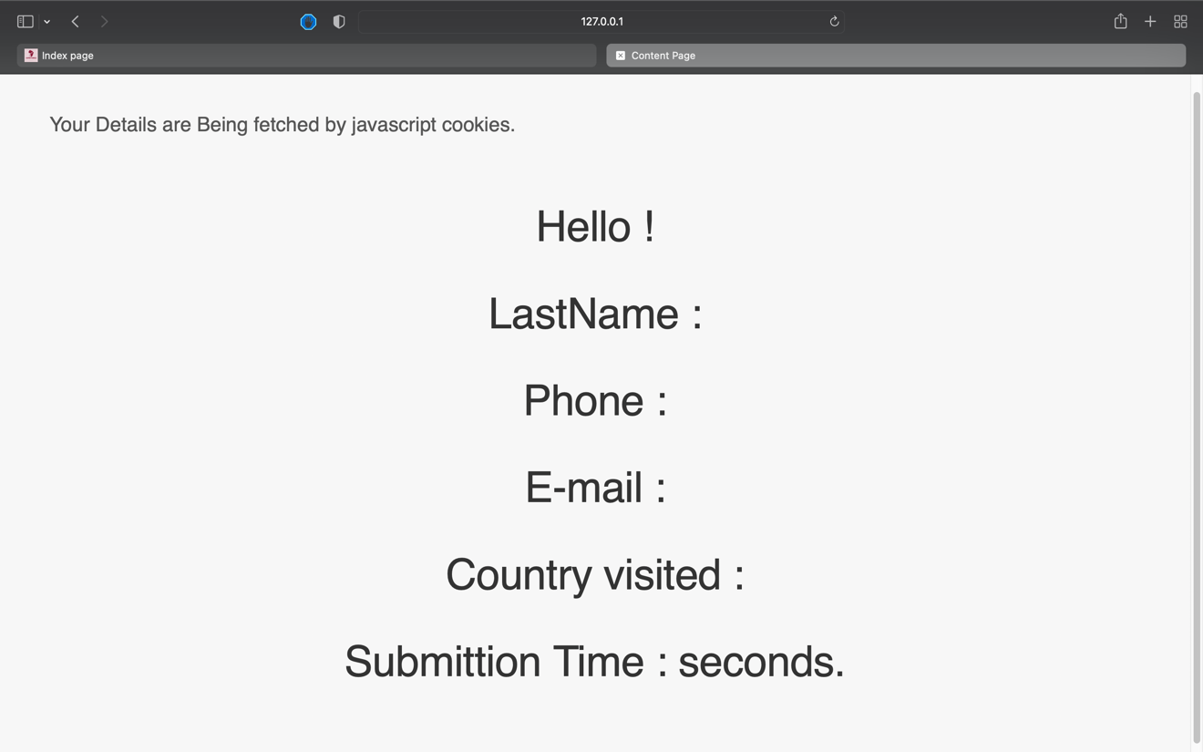

Step 9: Reference Page

Thank You,

Aafrin Sayani